Week 6 Homework:
Array List and TreeSet
By Lauren Geislinger
10/04/2020

Part 1:
Use the Array List (Must do this in week 6)
Use Java Class to Store Data Elements
Then add that class instance to the collection
I used my Array List and data set form the in-class assignment. For the in-class assignment, I was not able to store the data elements, but for this homework, I had the CSV file data write to a new output file. I also had a timer function which shows how fast this data will compile and print out. I did create a Java class called userData, and included the 5 elements separated by commas, but I was not able to implement it correctly for the array list. I was able to sort the data output into its own file. Also, the timer from the previous exercise still worked.

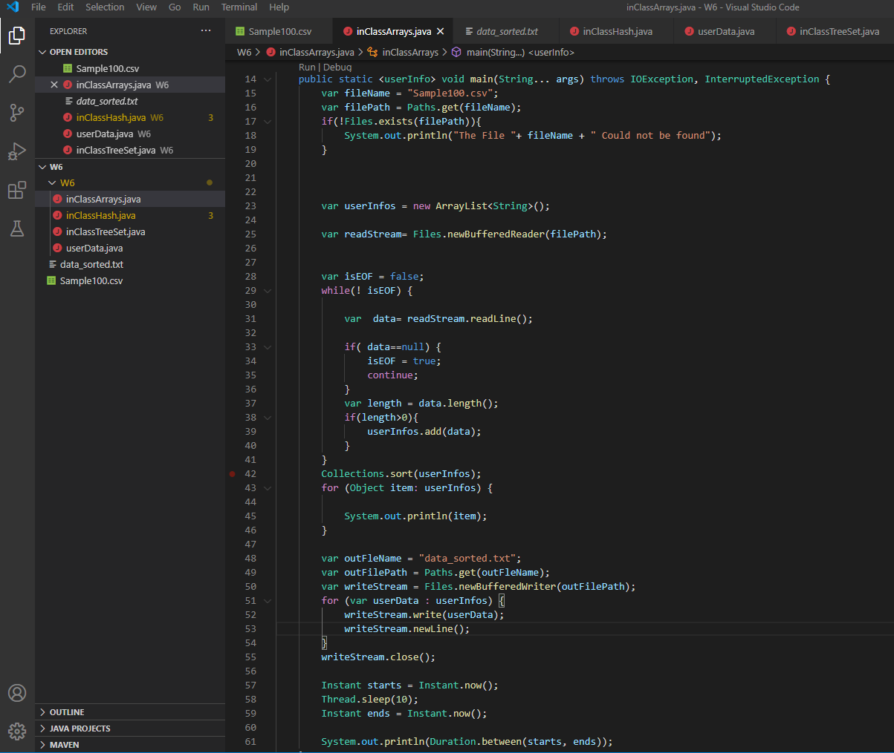
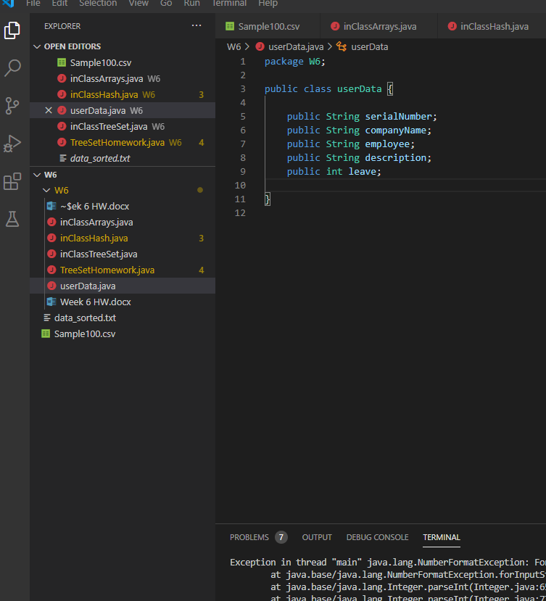
Part 2:
Use TreeSet
And write the data in reverse set into a new file.
Find Average on a Data Element
I used data.split to split the elements at the commas in the CSV file. I also attempted to use the userData Class I made with leave set to an integer, since all of those data inputs were 10 or less.
This wasn’t working, it threw an IOException error.
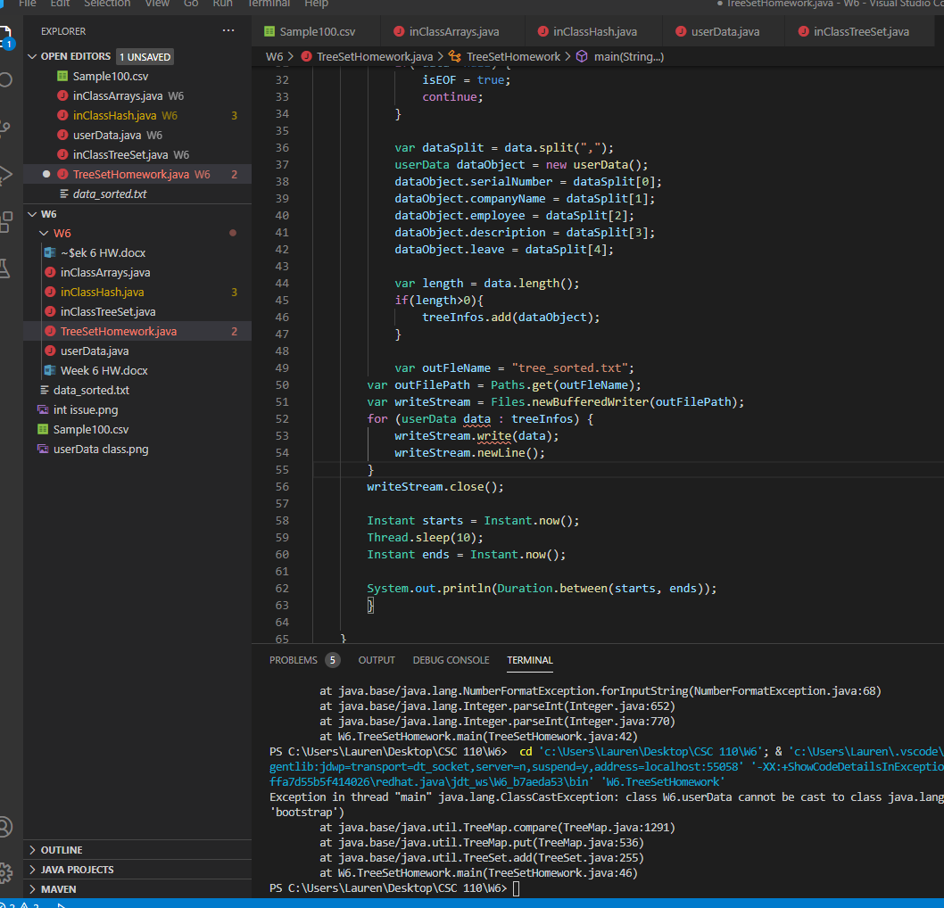

I am unable to get my Treeset to print in the opposite direction. I wanted to create a txt output file, but this isn’t working. I know I need to use the descendingSet() method but I am not sure where. The data does appear to read from the UserData Class I created.
I am also unsure how to obtain an average. I believe I can do it for my Array List by using getAverage(), but for the TreeSet, I was unable to find any method to obtain an average.

